**~~~~~~~~~~~~~~~~~~~~~~~~~~~~~~~ Name- SUKAINA INAM NAQVI Examination Roll Number- 20020570033**

**College Roll Number- 20201426**

**Semester -III**

**Subject- Computer Networks Practical Exam Outputs**

**~~~~~~~~~~~~~~~~~~~~~~~~~~~~~~~**

**Question 1:-**

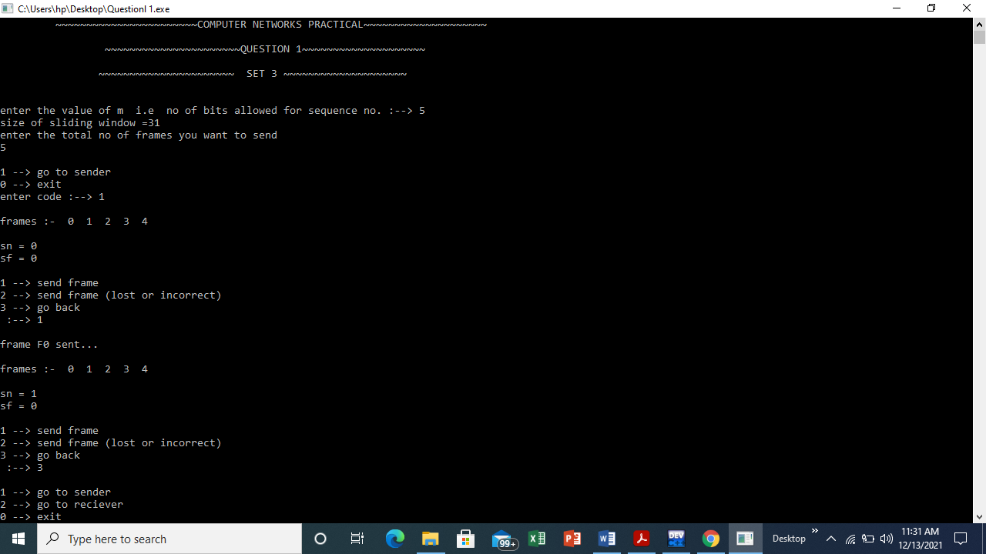

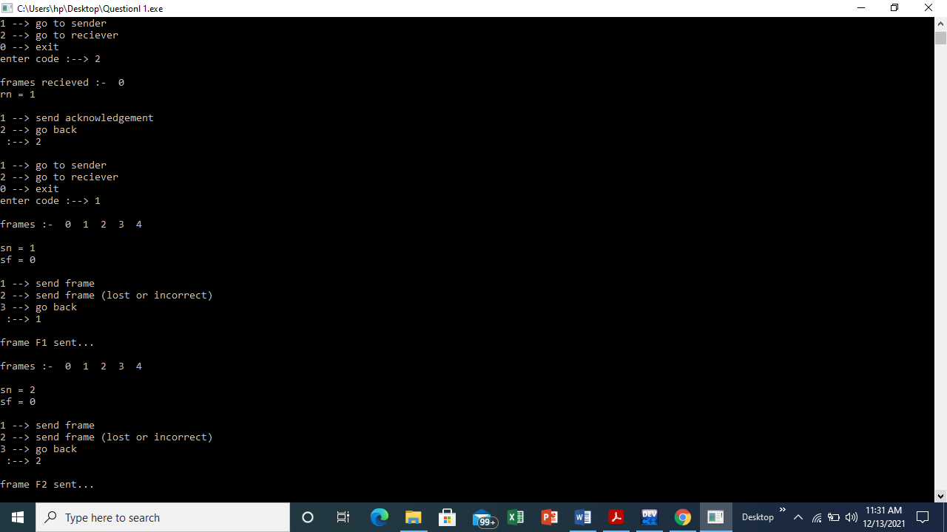

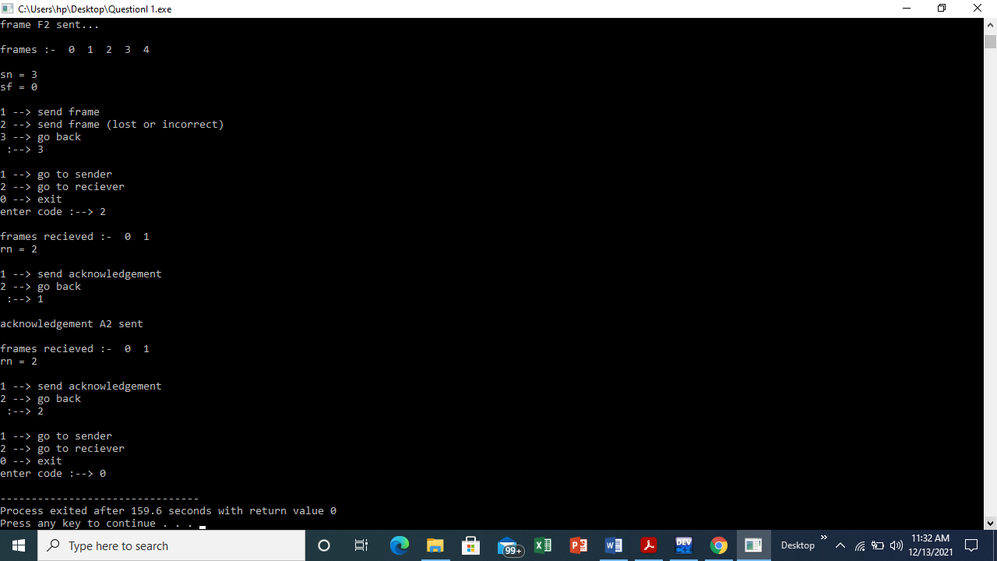

**Question 2:-**

